# PROJECT DESIGN PHASE – II SOLUTION REQUIREMENTS

|  |  |
| --- | --- |
| Date | 14 October 2022 |
| Project Id | PNT2022TMID30520 |
| Project Name | AI-powered Nutrition Analyzer for  Fitness Enthusiasts |

**Solution Requirements:**

# Functional requirement:

Following are the functional requirements of the proposed solution.

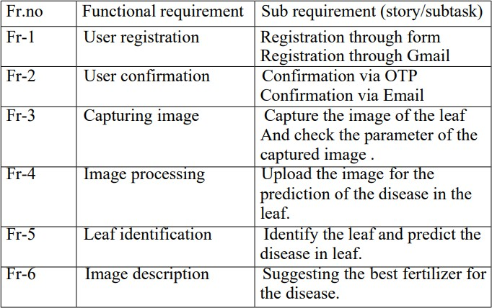

# Non-functional requirement:

Following are the non-functional requirement of the proposed solution.

